DAILY ONLINE ACTIVITIES SUMMARY

Date: |  | 20/05/2020 |  |  |  |  | Name: | Suhas prasad shetty
Sem & Sec |  | 8th- B |  |  |  |  | USN: | 4AL16CS080
 |  |  |  |  | Online Test Summary
Subject |  |  | Internet of Things
Max. Marks |  |  | 30 |  |  | Score |  | 26
 |  |  |  | Certification Course Summary
Course |  | Amazon training and Certification
Certificate Provider |  |  |  | AWS |  | Duration |  |  | 45 mins
 |  |  |  |  | Coding Challenges

Problem Statement:
1) Write a C Program to Reverse a Linked List in groups of given size.

Status: Executed

Uploaded the report in Github | Yes
If yes Repository name | Online certification course
Uploaded the report in slack | Yes

Online Test Details:

Certification Course Details:
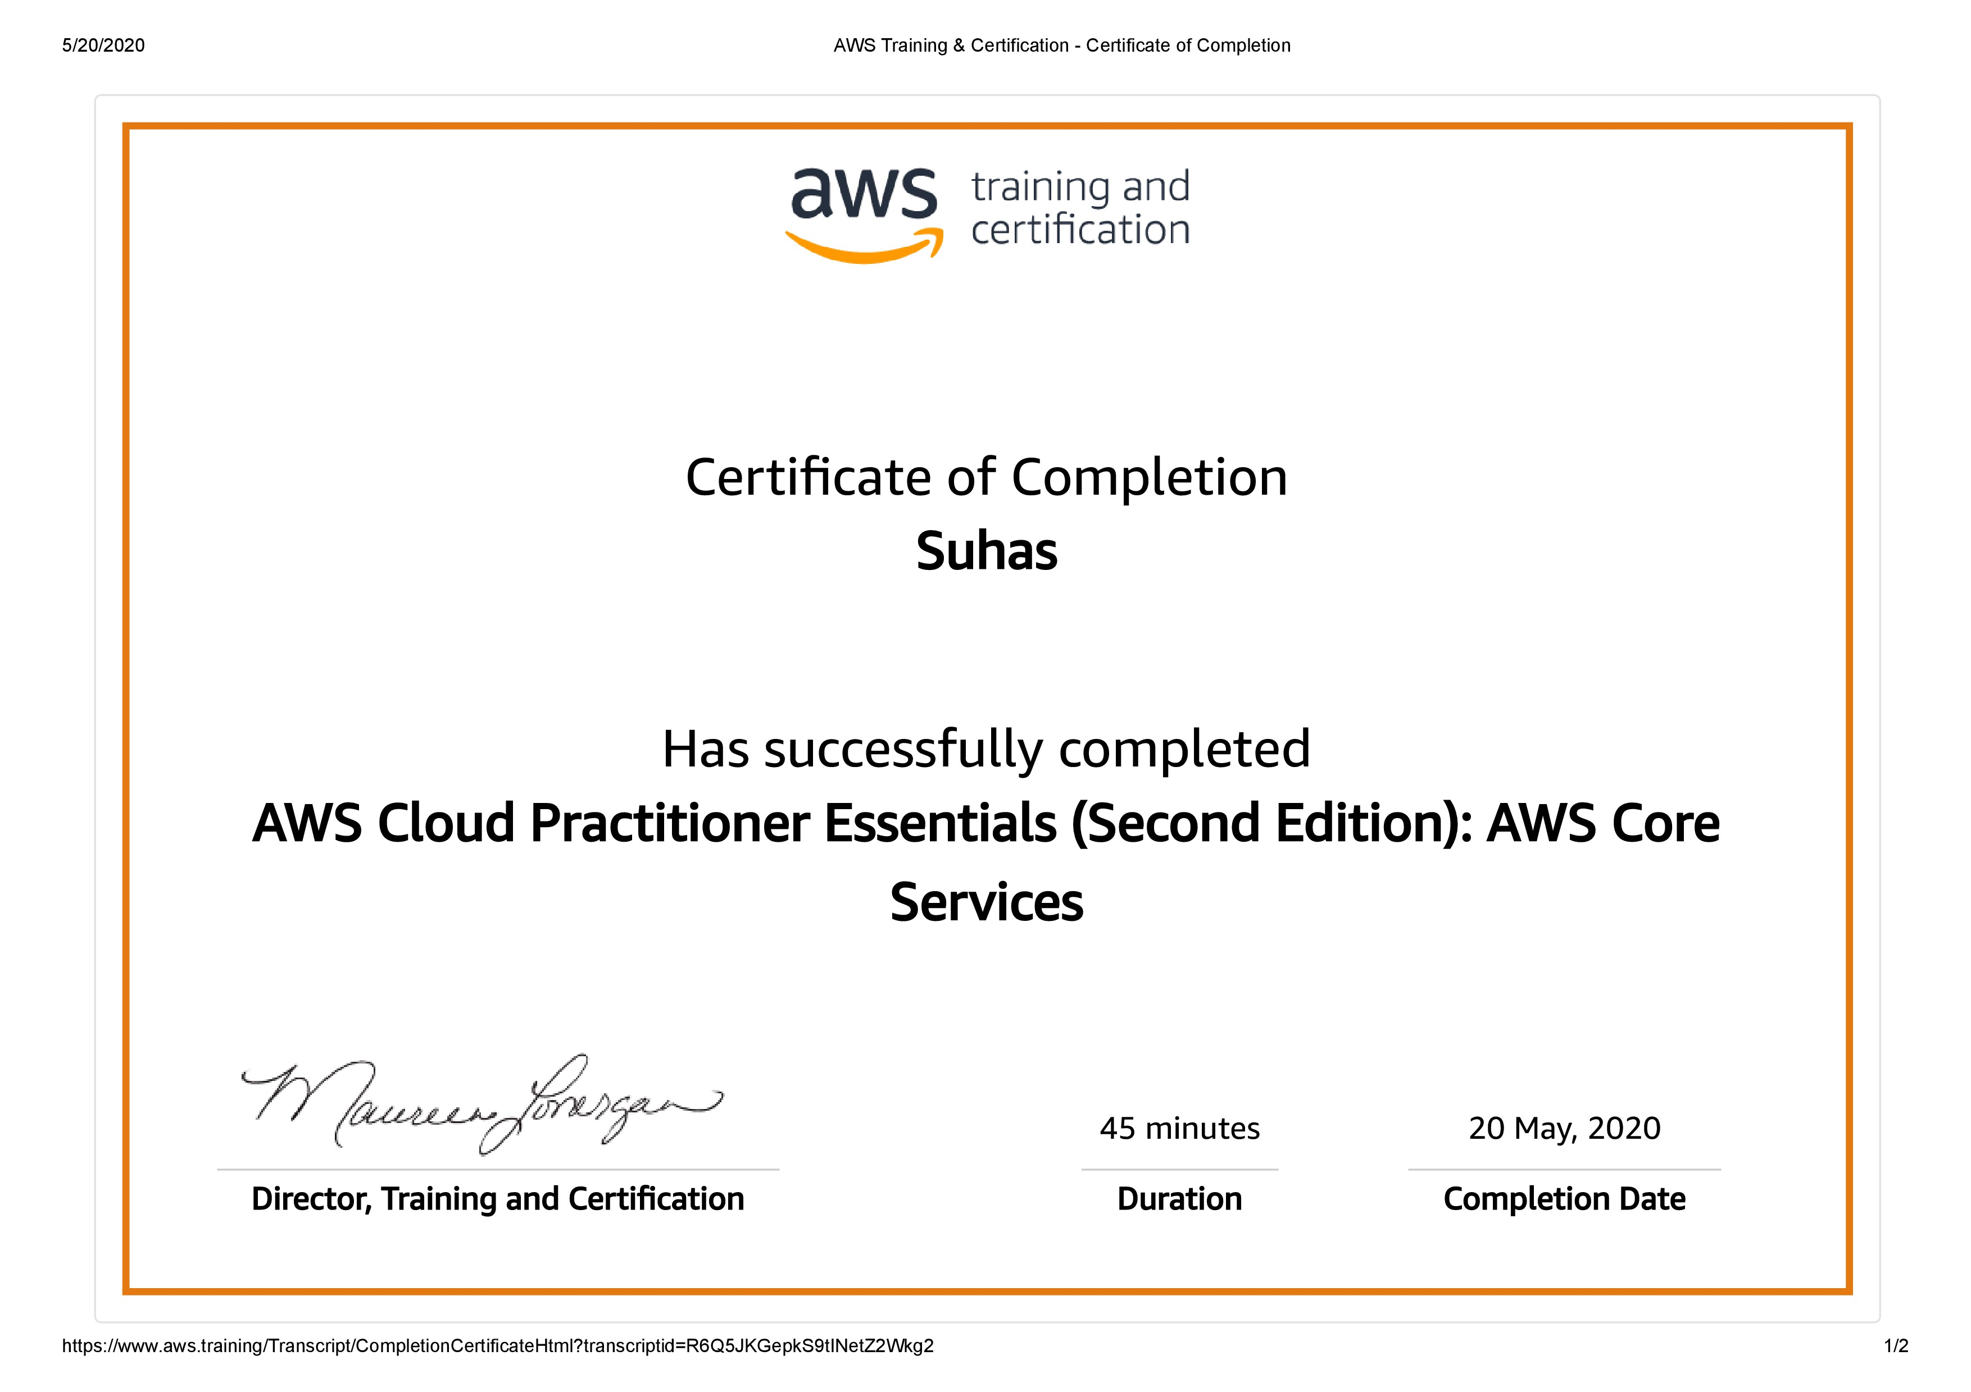

Coding Challenges Details:

- struct Node

{

int data;

struct Node* next; };

pointer to the new head node. /

struct Node reverse (struct Node head, int k)

{

struct Node current = head;

struct Node next = NULL;

struct Node prev = NULL;

int count = 0;

while (current != NULL && count < k)

{

next = current->next;

current->next = prev;

prev = current;

current = next;

count++;

}

if (next != NULL)

head->next = reverse(next, k);

return prev;

}

void push(struct Node** head_ref, int new_data)

{

struct Node* new_node =

(struct Node*) malloc(sizeof(struct Node));

new_node->data = new_data;

new_node->next = (*head_ref);

(*head_ref) = new_node;

}

void printList(struct Node *node)

{

while (node != NULL)

{

printf("%d ", node->data);

node = node->next;

}

int main(void)

{

struct Node* head = NULL;

push(&head, 8);
push(&head, 7);

push(&head, 6);

push(&head, 5);

push(&head, 4);

push(&head, 3);

push(&head, 2);

push(&head, 1);

printf("\nGiven linked list \n");

printList(head);

head = reverse(head, 2);

printf("\nReversed Linked list \n");

printList(head);

return(0);

